Introduction to Amazon DynamoDB

**Lab overview:**

* **Task 1: Create a New Table.**
* In this task, you create a new table in DynamoDB, named Music. Each table requires a Primary Key that is used to partition data across DynamoDB servers. A table can also have a Sort Key. The combination of Primary Key and Sort Key uniquely identifies each item in a DynamoDB table.

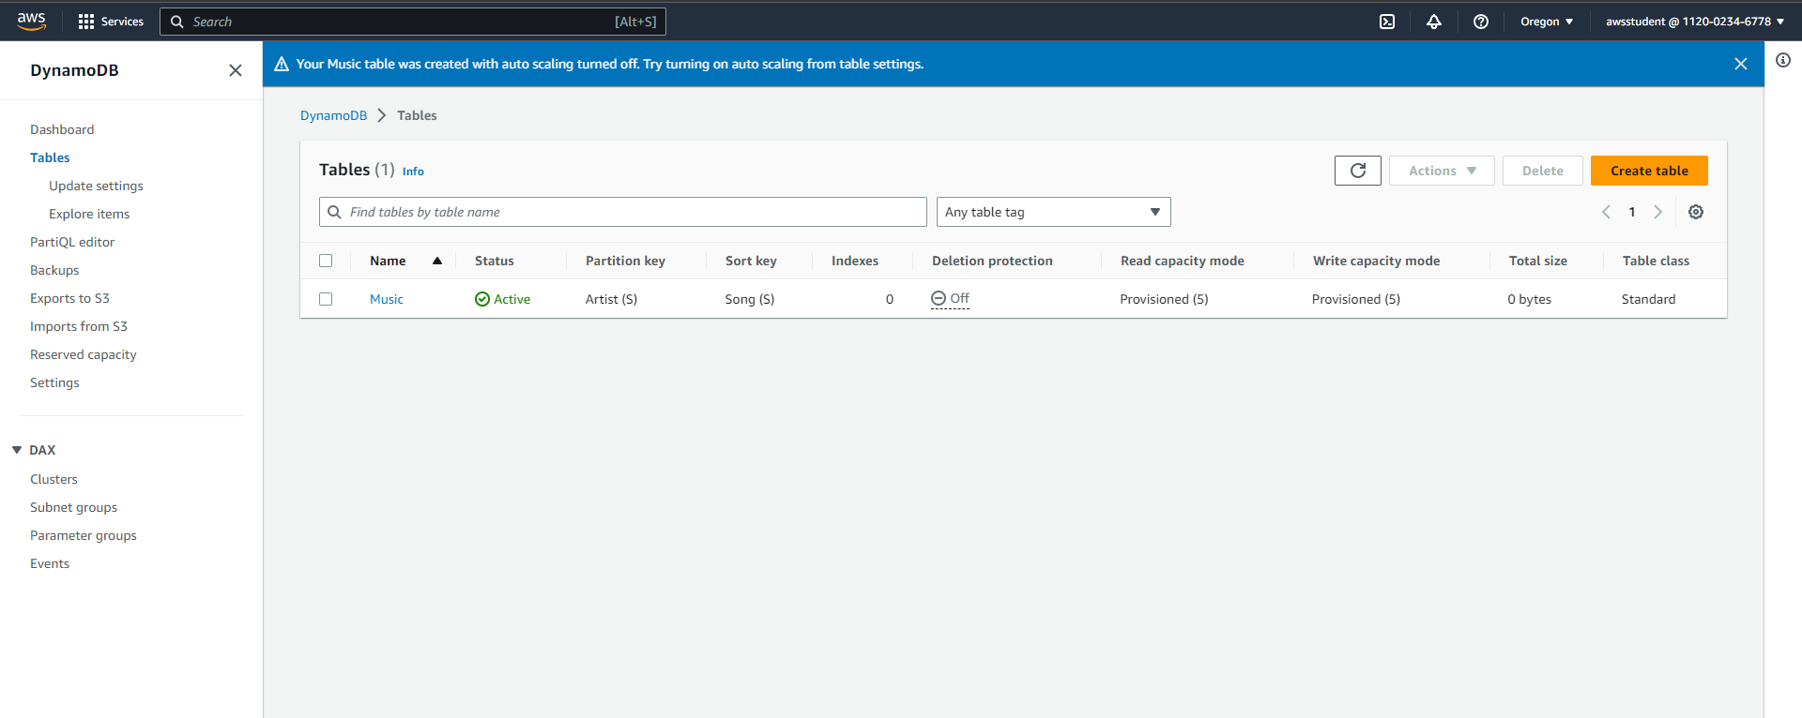

* **Task 2: Add Data.**
* In this task, you add data to the Music table. A table is a collection of data on a particular topic.
* Each table contains multiple items. An item is a group of attributes that is uniquely identifiable among all of the other items. Items in DynamoDB are similar in many ways to rows in other database systems. In DynamoDB, there is no limit to the number of items you can store in a table.
* Each item is composed of one or more attributes. An attribute is a fundamental data element, something that does not need to be broken down any further. For example, an item in a Music table contains attributes such as Song and Artist. Attributes in DynamoDB are similar columns in other database systems, but each item (row) can have different attributes (columns).
* When you write an item to a DynamoDB table, only the Primary Key and Sort Key (if used) are required. Other than these fields, the table does not require a schema. This means that you can add attributes to one item that may be different to the attributes on other items.

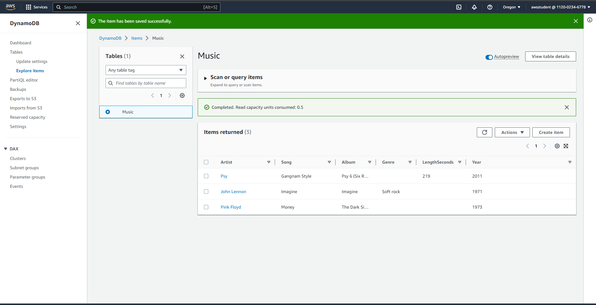

* **Task 3: Modify an Existing Item.**
* In this task we will modify an Existing item from year 2011 to 2012.



* **Task 4: Query the Table.**
* In this task, you query the Music table. There are two ways to query a DynamoDB table: Query and Scan.

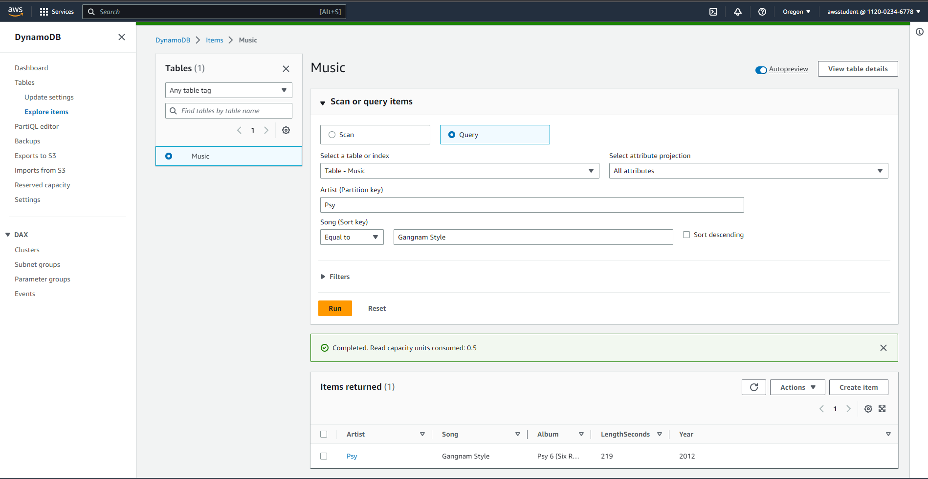

* A query operation finds items based on Primary Key and optionally Sort Key. It is fully indexed, so it runs very fast.

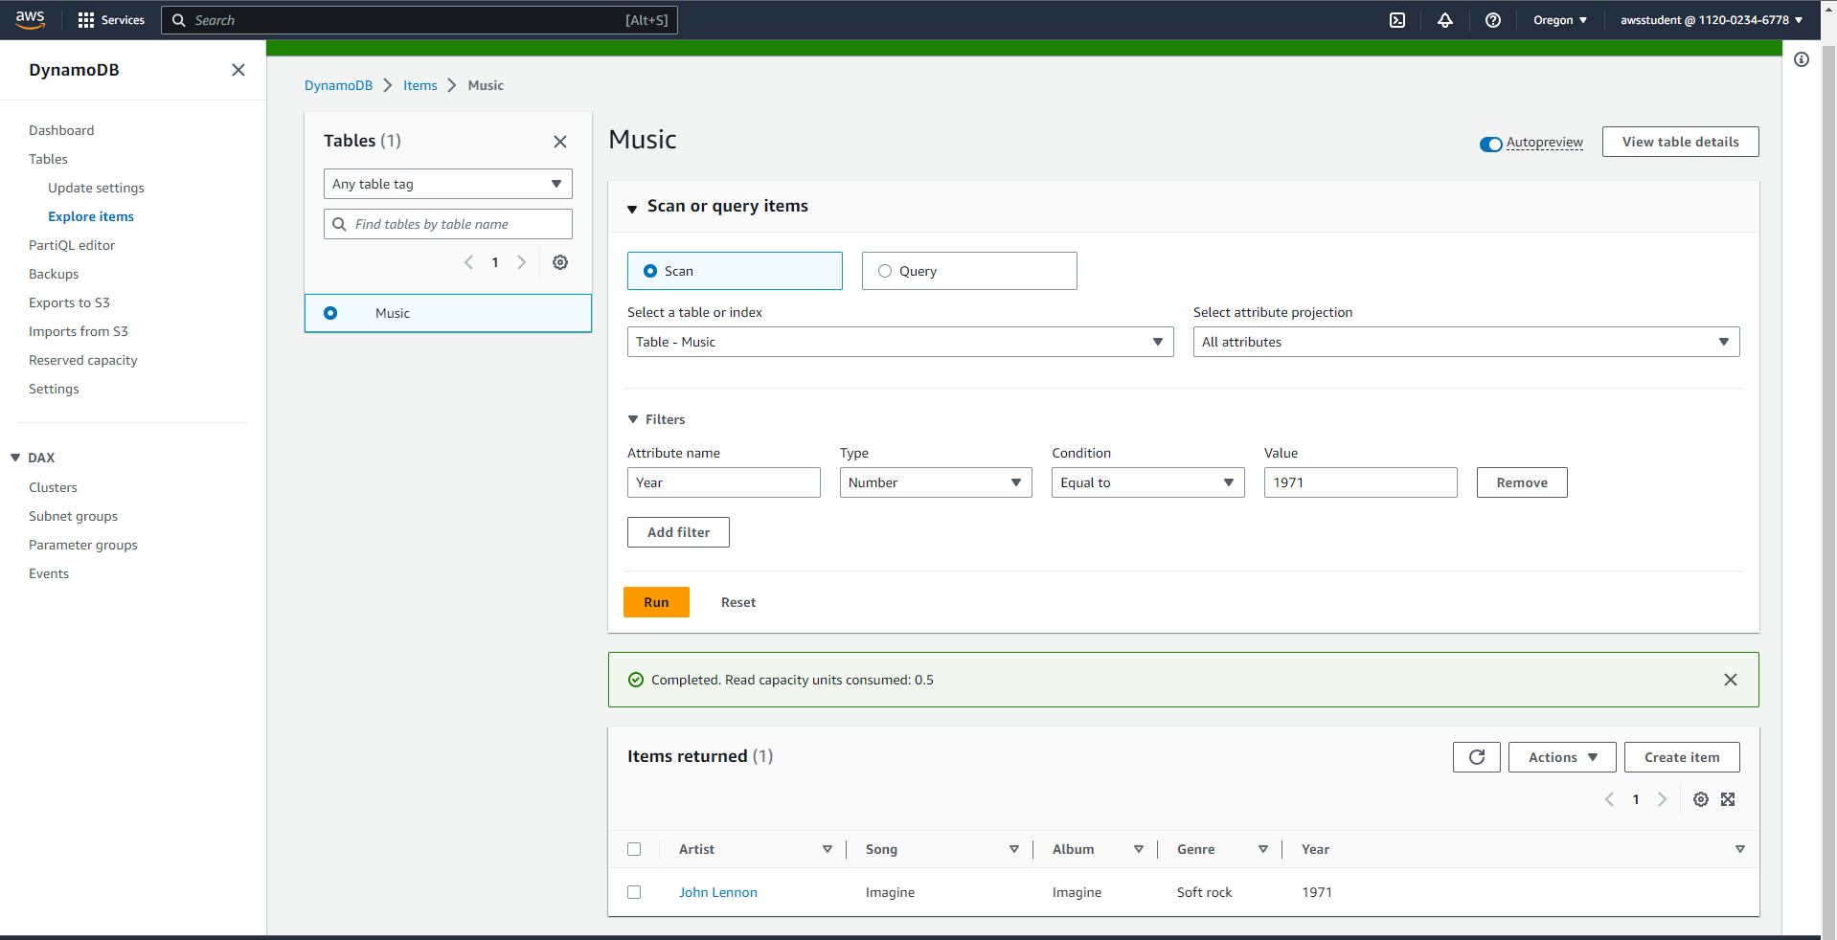

* **Task 5: Delete the Table.**
* In this task, we will delete the Music table, which also deletes all the data in the table.

